**13. Parse Tree Generation Using Context-Free Grammar**

**Aim:**  
To generate a parse tree for a given sentence using a CFG.

**Algorithm:**

1. Define a CFG.
2. Parse the input sentence.
3. Display the parse tree using NLTK.

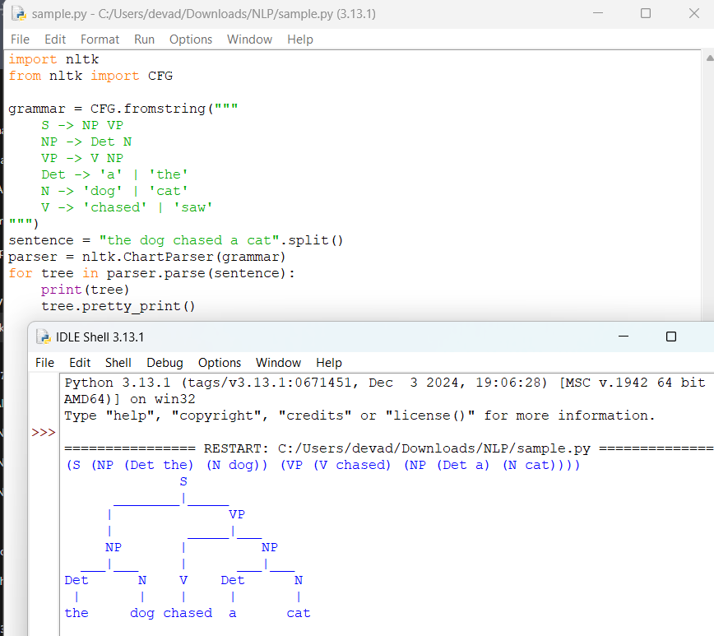**Result:**  
The parse tree is generated successfully for the given sentence.